The eTools team designed a “Country Office Administrator” role for one or two focal points in a Country Office to be able to amend or delete data that was entered incorrectly in eTools.
IMPORTANT!
Please note that you should be using this role only under exceptional circumstances such as when user made an error and the front end operations cannot amend that mistake. Please be especially careful with deleting as once something is deleted from the admin panel, the engineers will not be able to restore it. If you are not certain, please contact Nik at ntrncic@unicef.org or your Regional Support Specialist.

What are the Key Permissions/Functions of the Country Administrator Role?
For any processes that require amendments to PCAs/PDs/SSFAs, the country office should follow the amendment process as highlighted in the relevant procedures.
 | Activities | Permissions | Notes
Partnership Management Portal (PMP)
1 | Change uploaded PCA amendment file | YES | Can be completed by clicking the Agreement Amendment link in the admin panel
2 | PCA status, dates, authorized officers, reference number can be changed. PCAs and PCA amendments can also be deleted | YES | Can be completed by clicking in the Agreement link in the admin panel. Please note when deleting a PCA, PDs associated with the PCAs will also be deleted.
3 | PD /SSFA status, dates, authorized officers can be changed. PDs can also be deleted. | YES | Can be completed by clicking in the Interventions link in the admin panel. Please note when trying to deleting a PDs/SSFAs, those that are already linked to PRP cannot be deleted.
4 | Uploaded PD/SSFA amendment file can be changed | YES | Can be completed by clicking the Intervention Amendments link in the admin panel
5 | Upload Partner core values assessment | YES | Can be completed by clicking on the Partner Organizations link
6 | Changes to Partner details | NO | Information synced from Vision should not be changed as the information will be replaced from Vision during the next sync
7 | Results framework | NO | This should be changed by changing the status of the PD into draft and amending the indicators on the front end. This also applies to associated reporting requirements.
8 | Delete PD/SSFA amendments | NO
9 | Edit user roles and permissions | NO | This request should be sent to GSSC helpdesk
TRIP Management Portal (TRIPS)
1 | TRIP dates, office, section, supervisor, traveler can be changed | YES | Can be completed by clicking on Travels link in the admin panel
2 | Change Trip status and attachments | NO
3 | Change trip activities, partner, travel type, results, PD/SSFA | YES | Can be completed by clicking on Travel Activities link in the admin panel
Third Party Monitoring Module (TPM)
1 | Change TPM dates, visit information, TPM focal points, UNICEF focal points, office of UNICEF focal point, section of UNICEF focal point, trip activities, locations and mark as Programmatic visit | YES
Financial Assurance Module (FAM)
1 | Change report, findings and attachments submitted by auditor | NO | This should be completed on the front end by the auditor, once you have changed the status of the engagement to IP contacted (in the backend)
2 | Change status, dates, Implementing Partner, open fields, assurance staff members, IP authorized officer | YES | Can be completed by clicking on the type of engagement you are changing in the Auditor Portal section of the admin panel (ex. For changes to Audits click on the Audits link, for micro assessments click on the micro assessments link)
Action Points
1 | Delete Action Point, change description, dates, implementing partner, output, PD/SSFA, engagement, TPM activity, Trip and description | YES | Can be completed by clicking on Action Points link in the admin panel
2 | Change status, actions taken, Office, Section, assigned by/to | NO

How to access eTools admin panel?
- Log into eTools using your UNICEF email and password

- Click on App selector
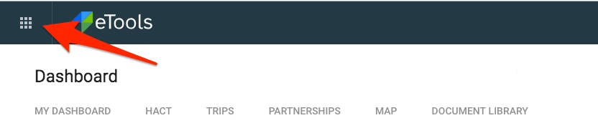
- Select Admin
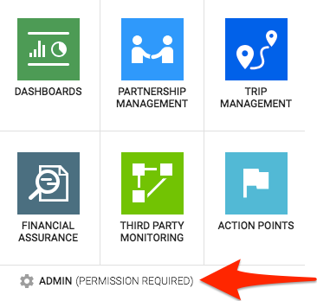
- The admin panel will open
What functions can Country Office Administrator do?
Through the eTools Admin Panel, the Country Officer Administrator will be able to do the following functions in the below modules:

Partnership Management Module
- Partners page

- Upload the correct Core Value Assessment
- Scroll down to Partners Section
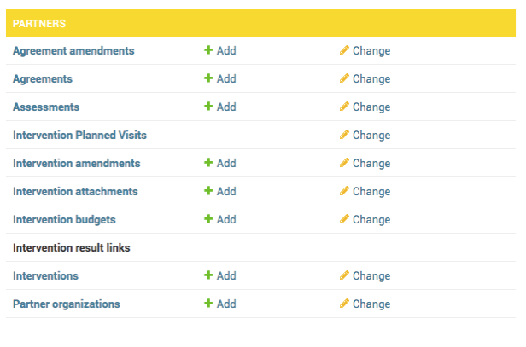

- Click on Partner organizations or Change
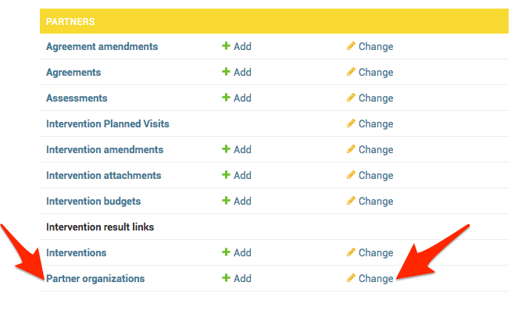
- Click on the name of the partner to open their details
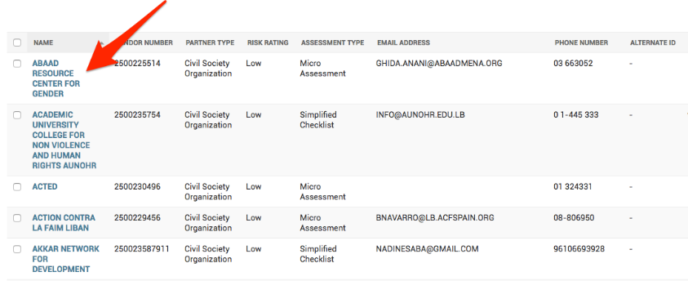

- Scroll down to Core Values Assessment section
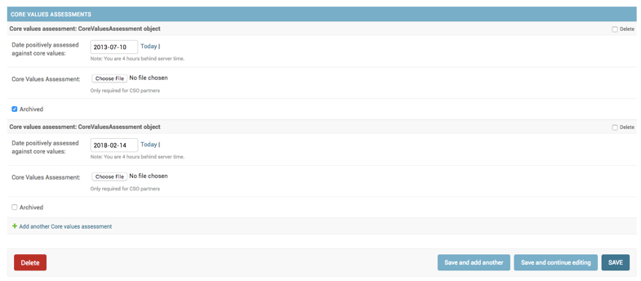
- In Core Values Assessment section, go to Core Values Assessment and check mark the box to delete the document and then click on Save (located at the bottom of the page).
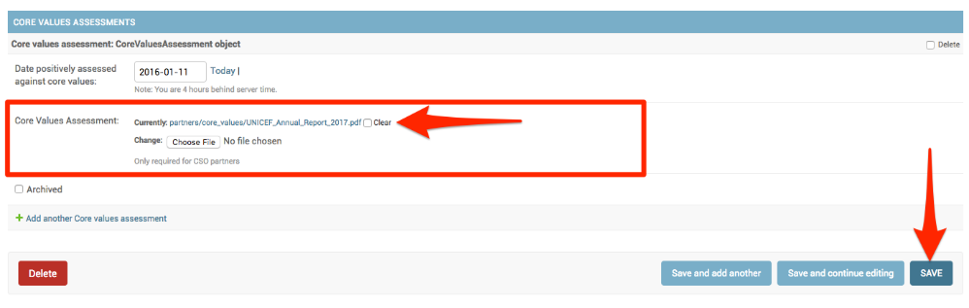
- You will be then taken back to the list of partners, so click again on the name of that partner and scroll down to Core Values Assessment section. Upload the correct Core Values Assessment and click on Save.

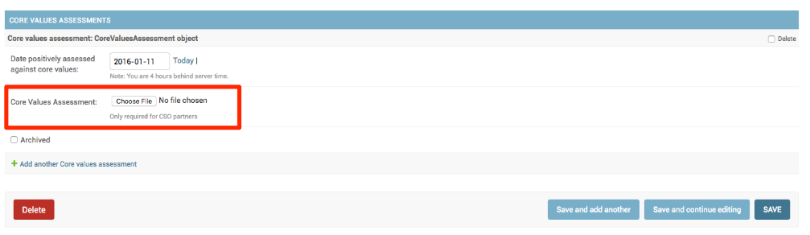

- Delete Assessment
- Scroll down to Partners Section
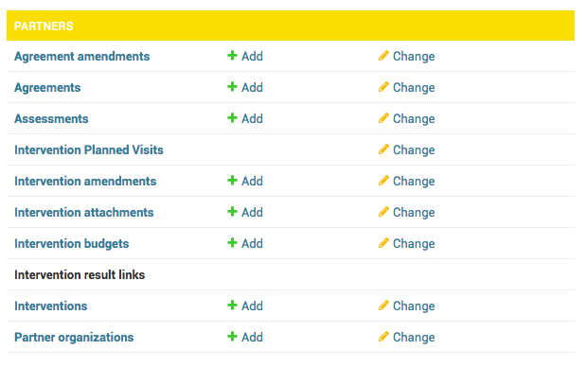
- Click on Assessments or Change
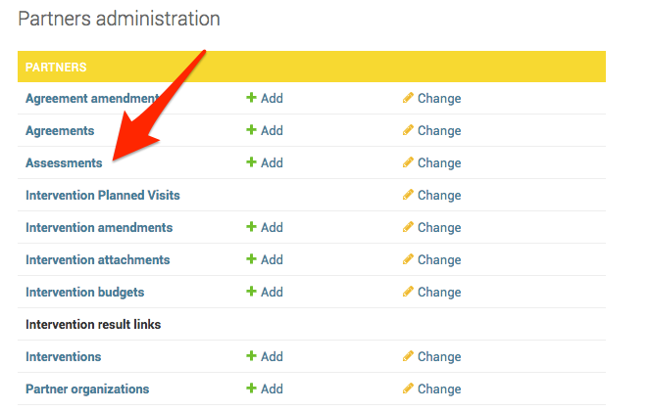
- Select Assessment you need to delete
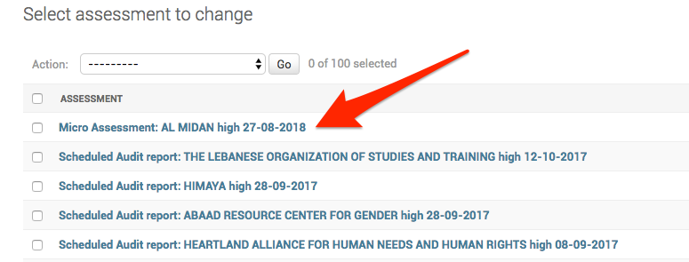
- Scroll down and click on Delete
- The system will ask you one more time to confirm that you want to delete the entire intervention. Click on Yes, I’m sure

- Agreements (PCA, SSFA) data:
- Upload the correct Agreement (if attachment in eTools is incorrect)
- Scroll down to Partners Section
- Click on Agreements or Change
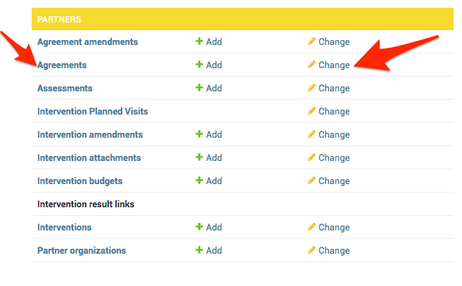
- Click on the name of the partner to open their details
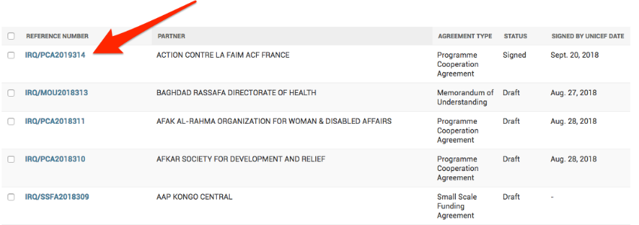

- Scroll down to Attachment and click on Delete
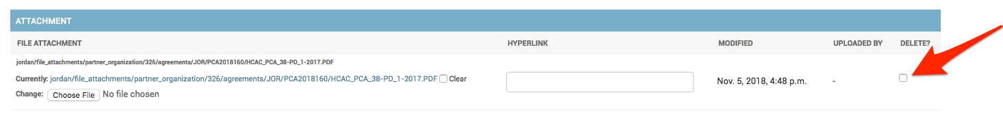
IMPORTANT!
Take note of the Reference Number of the PCA as it may automatically change in the next step and adjustments may be necessary.

- Click on Save.
NOTE: Do not click on red delete button as it deletes entire Agreement!!

IMPORTANT!
At this point you must check if the reference number of your agreement has changed. If so, then go back to the admin panel and manually adjust the reference number. To adjust the reference number, follow the below steps:

- Go to Partners and click on Agreements
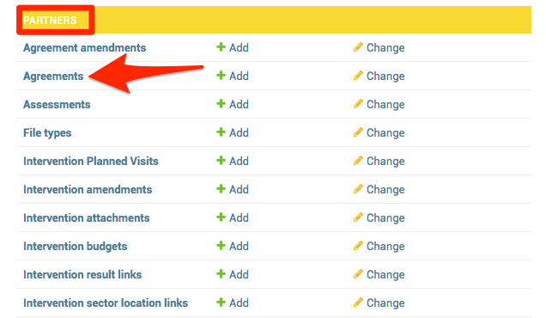

- Open PCA that must be in draft status (in order to change its reference number)
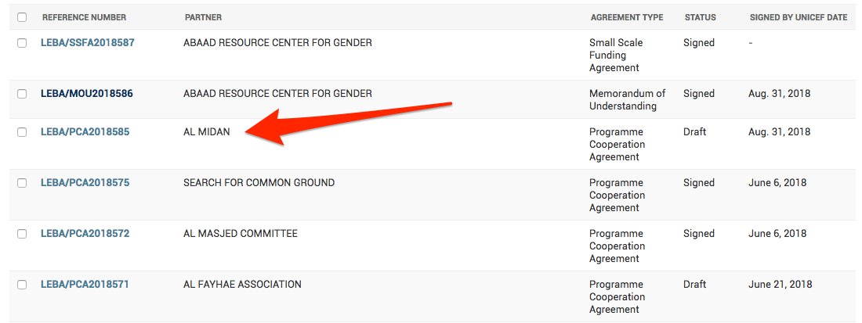

- Change the reference number and click Save at the bottom of the page
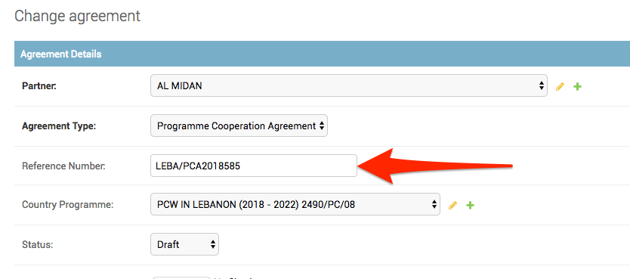

- Upload the correct Signed Amendment (if attachment in eTools is incorrect) and change Signed Date
- Scroll down to Partners Section
- Click on Agreement amendments or Change
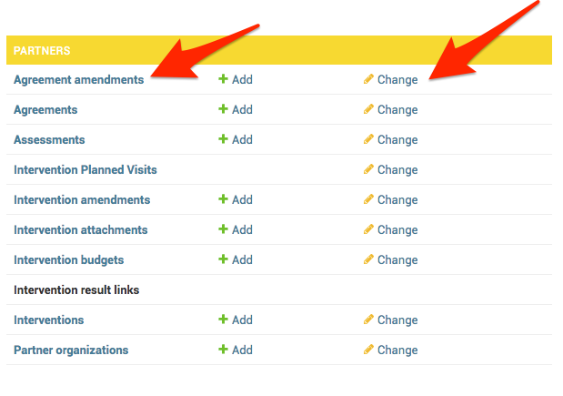
- Select agreement amendment which you want to correct
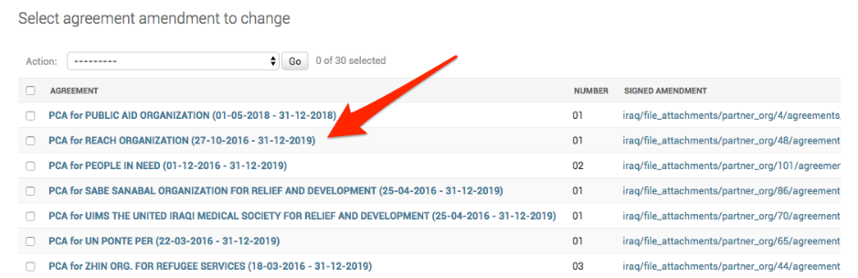
- In Change Agreement Amendment, go to Signed Amendment and check mark the box to delete the amendment and click on Save (located at the bottom of the page)
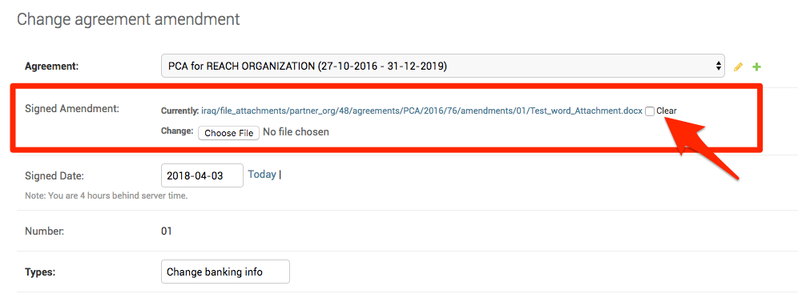
- You will be taken back to the list of partners, so click again on the name of the partner and then go to Signed Amendment and upload the correct signed amendment.
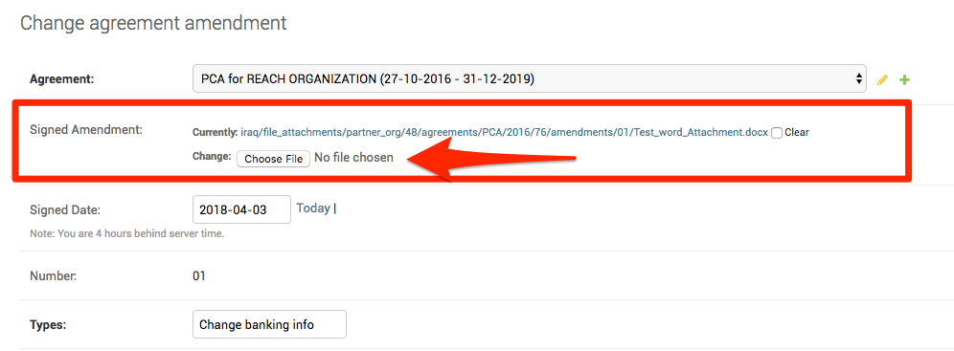
- Should you need to change the Signed Date, go to Signed Date and change it. Do not forget to click on Save (located at the bottom of the page).

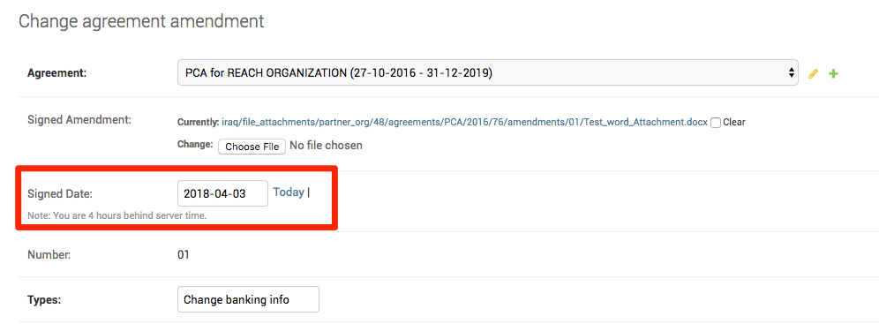

- Delete Agreement Amendments
- Scroll down to Partners Section
- Click on Agreement Amendments or Change
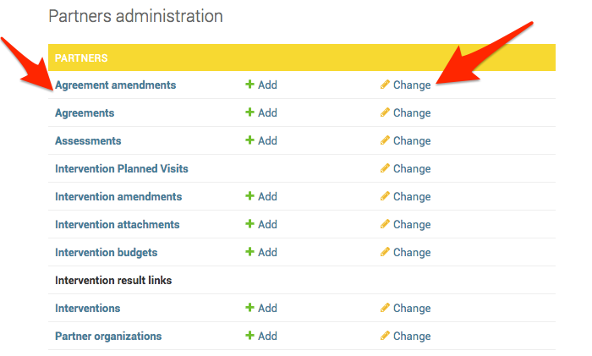
- Select which agreement amendment you need to delete
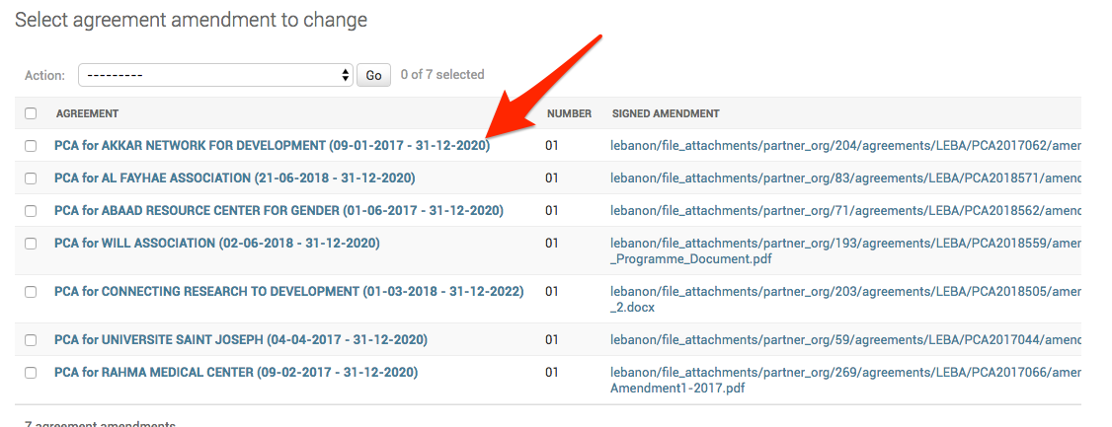
- Scroll down and click on Delete
- The system will ask you one more time to confirm that you want to delete the entire intervention. Click on Yes, I’m sure

- Intervention (PD, SSFA) data:
- Change status (i.e. from Ended to Active so that an amendment can be added)
- Scroll down to Partners Section
- Click on Interventions or Change
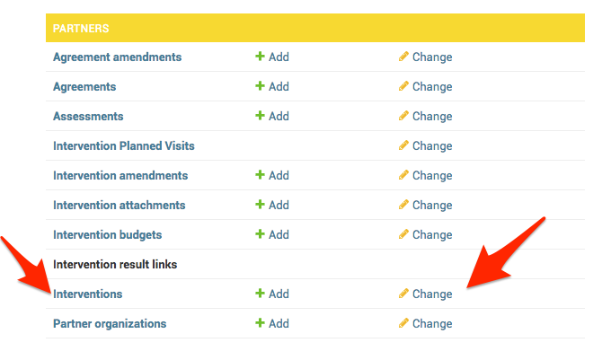
- Click on the name of the partner which PD/SSSFA status you want to change to open intervention details
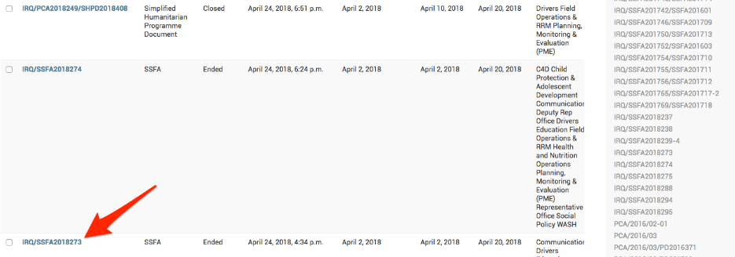
- In interventions detail page, go to Status and change it from Ended to Active and click Save (at the bottom of the page)
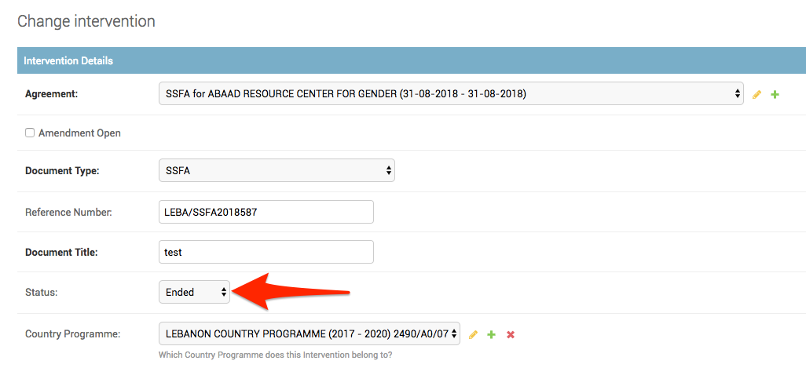

IMPORTANT!
Every time you click Save and the PD/SSFA is in draft status, the reference number will be re-generated. Take note of the reference number and adjust it manually if it has changed (see above).

- Upload the correct PD/SSFA (if attachment in eTools is incorrect)
- Scroll down to Partners Section
- Click on Interventions or Change
- Click on the Reference Number to open PD/SSFA
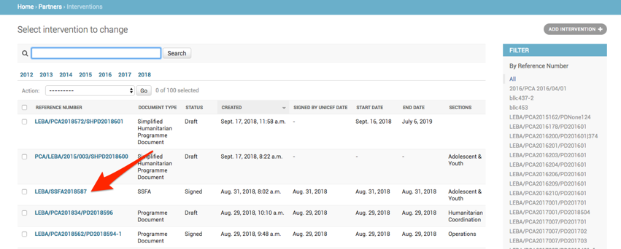
- Scroll down to Signed PD Document
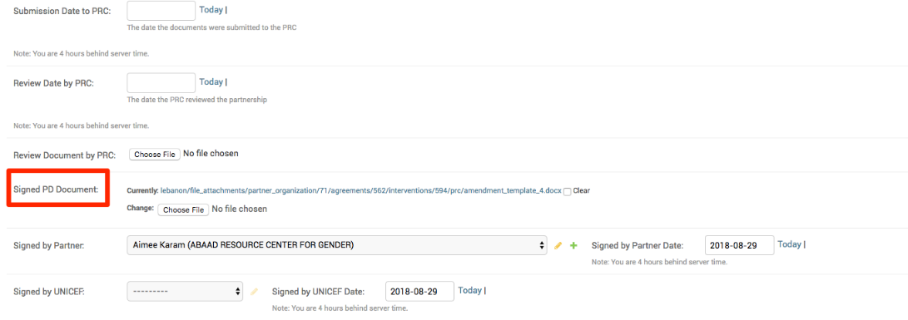
- Click on Choose file and select the correct PD and click on Save at the bottom of the page
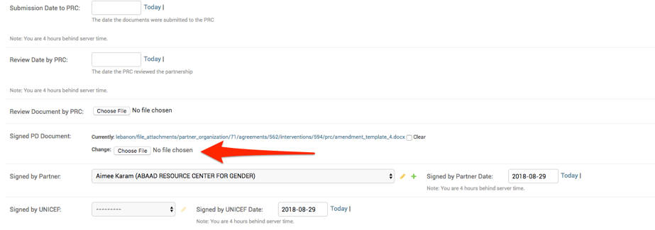
- Upload the correct PD/SSFA amendment and change amendment Signed Date
- Scroll down to Partners Section
- Click on Interventions Amendments or Change
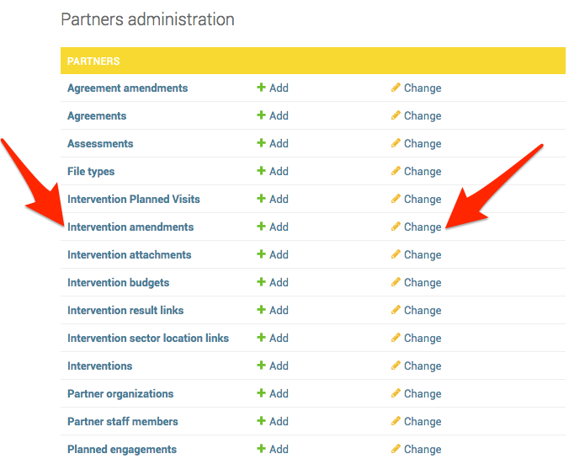

- Check mark the PD/SSFA amendment you wish to delete
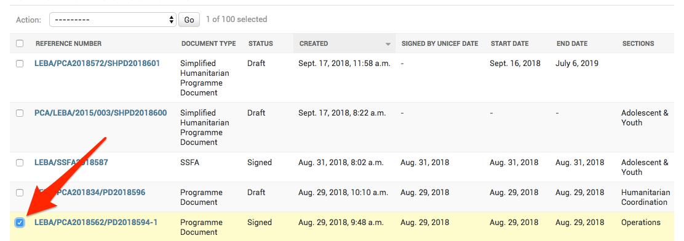

- Go up to Actions and select Delete selected intervention. Press Go
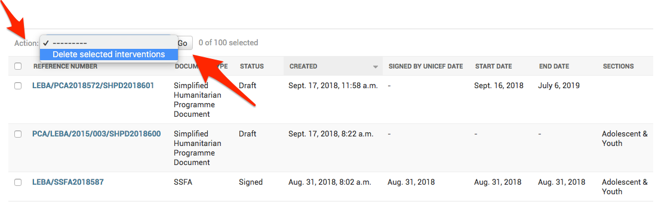

- The system will ask you one more time whether you are sure that you want to delete that PD/SSFA amendment. Click on Yes, I’m sure
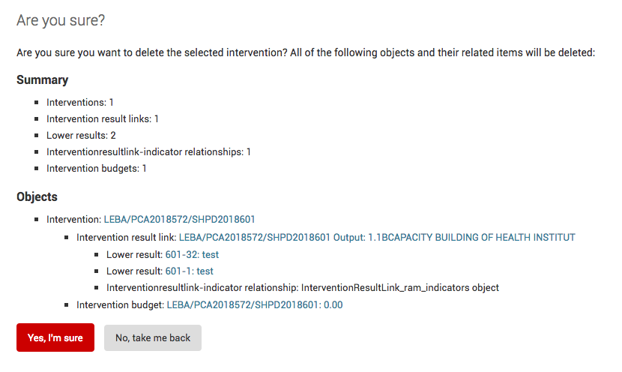

- Upload the correct PRC Review Document
- Scroll down to Partners Section
- Click on Interventions or change
- Click on the name of the partner
- Scroll down to Dates and Signatures section and go to Review Document by PRC. Check mark the box to delete the PRC. Click Save

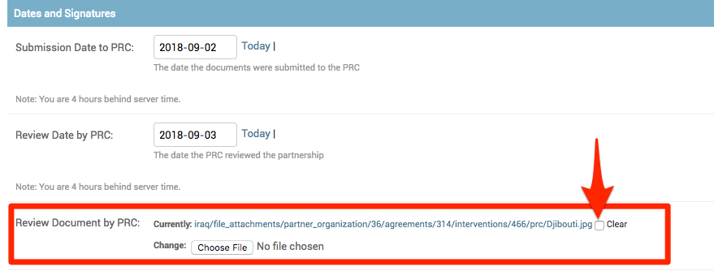

- You will be taken back to the list of partners, so click again on the partner’s name and scroll down to Dates and Signatures section. Then upload the correct PRC and click save.
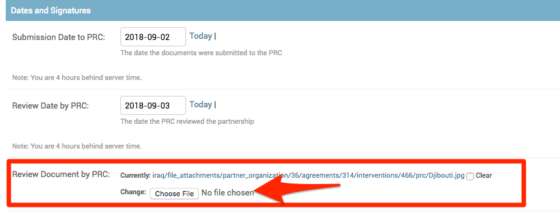

- Delete Interventions (should only be done if the intervention in eTools is incorrect)
- Scroll down to Partners Section
- Click on Interventions or change
- Click on the name of the partner
- Scroll down and click on Delete
- The system will ask you one more time to confirm that you want to delete the entire intervention. Click on Yes, I’m sure

Trip Management Module
- Amend or delete Trip Management data (i.e. dates, office, section, attachments and etc.)
- Scroll down to T2F Section
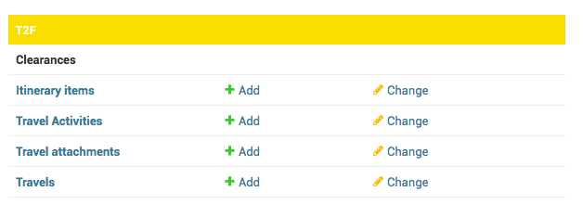
- Click on Itinerary Items or Change
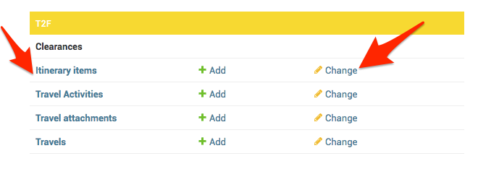
- Click on the trip you wish to amend or delete
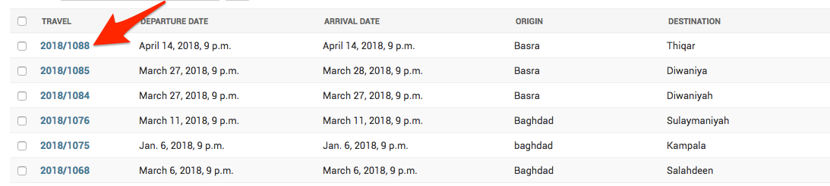
- Either make changes to the trip or click on the red delete button at the bottom of the page
- If you need to make changes to the trip, do not forget to click Save when you are done

- If you need to delete the trip, click Delete
- After you clicked delete, the system will ask you to confirm one more time that you want to delete the trip
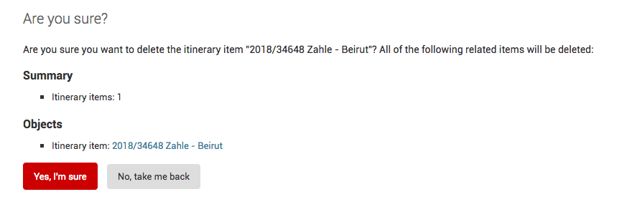
- Click on Yes, I’m sure

Action Points
- Amend or delete Action Point data (i.e. description, due date, supervisor)
- Go to Action Points
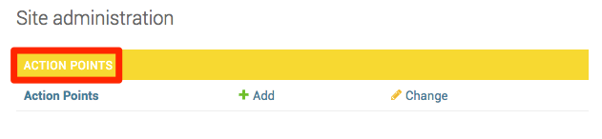
- Click on Action Points
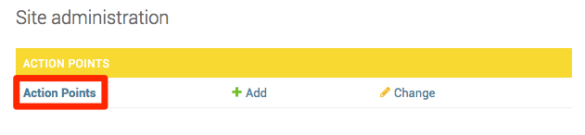
- Select the action point you want to amend or delete
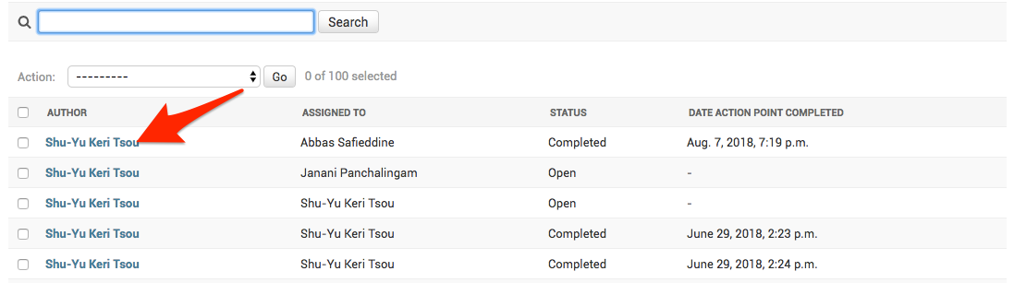
- You can either make changes to the action point or delete it
- If you need to make changes to the trip, do not forget to click Save when you are done

- If you need to delete the trip, click Delete
- After you clicked delete, the system will ask you to confirm one more time that you want to delete the trip
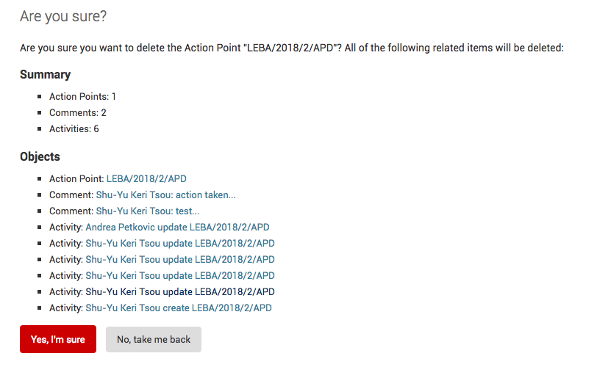
- Click on Yes, I’m sure

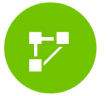Third Party Monitoring
- In order to (Change visit information or change TPM focal point for the visit)
- Scroll to the TPM list, then click on TPM visits
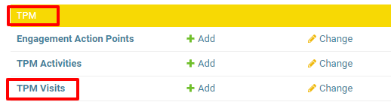
- You can either search or just click on the TPM visit from the list that you want to change.
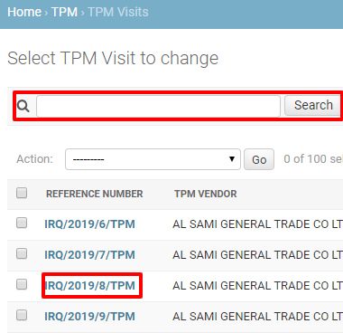
- To change the Visit information, scroll down and change the text field in Visit Information.
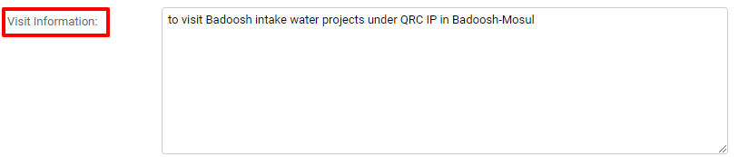
- To change the focal point, scroll down to the TPM Focal point field, if you want to add a new name select one or multiple TPM focal points in the left column and click on the arrow, if you want to remove a name, click on the name of the TPM focal point in the right column and click on the arrow.

- To add a TPM focal point:
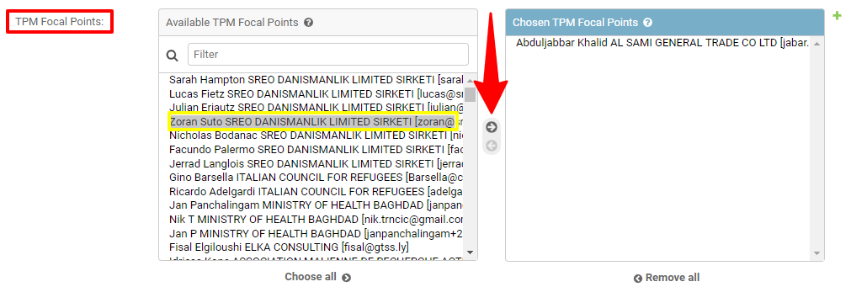
- To remove a TPM focal point:
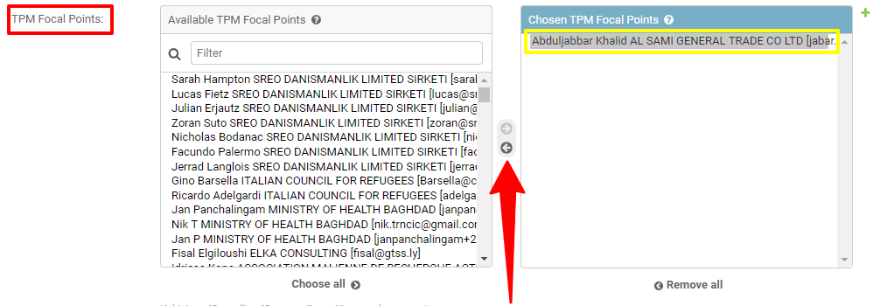
- Always click on save at the bottom of the page.
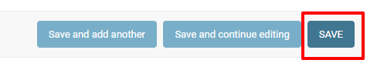

- In order to change TPM activities (Implementing partner, Intervention, CP output, location and the date of the activity)
- Scroll down to TPM list, then click on TPM Activities
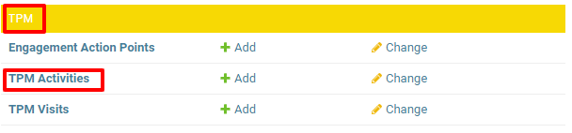
- You can either search or just click on the TPM visit from the list that you want to change.
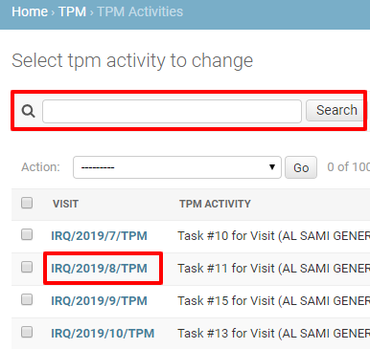
- Under the Change TPM activity field, click on the lookup icon to update Implementing partner, Intervention or CP output
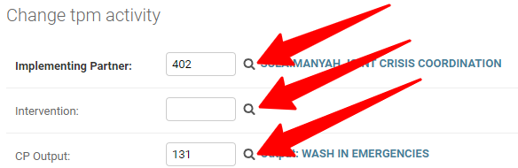
Once you click on the lookup icon, a new window will pop up and you will select the desirable choice. Then click on save button at the bottom of the page.

- To change the location of the Activity
- Under the Locations field, if you want to add a new location, select one or multiple location in the left column and click on the arrow, if you want to remove a location, click on the name of the location in the right column and click on the arrow.

- To add a new location:
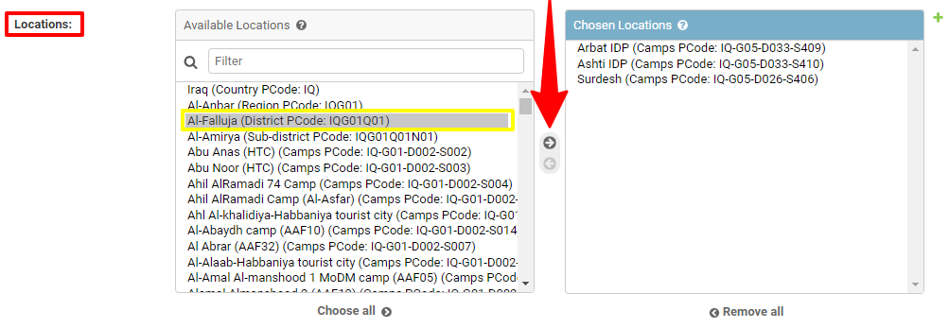
- To remove a location:
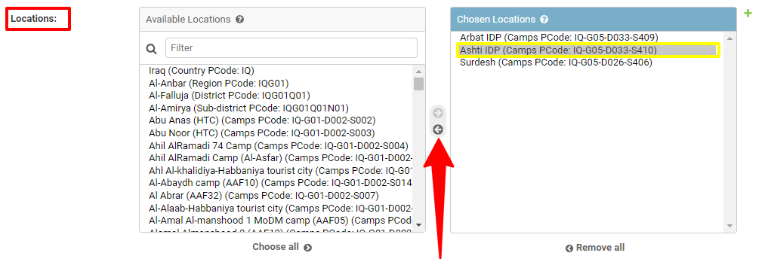
- Click on save at the bottom of the page

- In order to change the date of the Activity.
- Under the Date field, change the date of the activity.
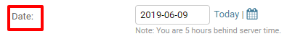

- In order to change the section of the of the UNICEF focal point,
- Under the section field, update the section by selecting from the drop-down list.

- To change the UNICEF focal point, scroll down to the UNICEF Focal points field, if you want to add a new name select one or multiple UNICEF focal points in the left column and click on the arrow, if you want to remove a UNICEF focal point, click on the name of the UNICEF focal point in the right column and click on the arrow.

- To add a UNICEF focal point:
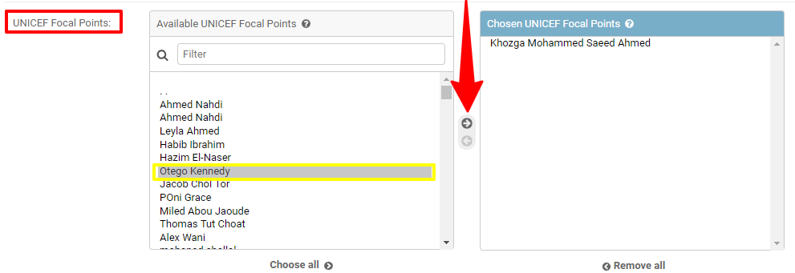
- To remove a UNICEF focal point:
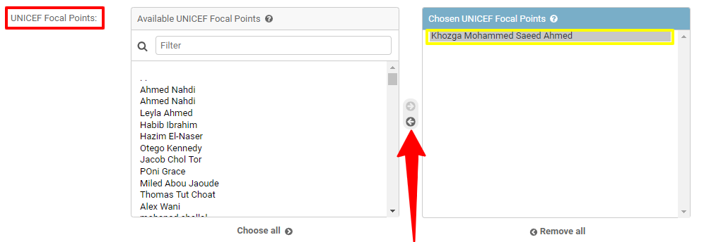
- Click on the save button at the bottom of the page.
- To change the office of UNICEF focal point, scroll down to the office of UNICEF Focal points field, if you want to add a new UNICEF focal points, select the office of UNICEF focal points in the left column and click on the arrow, if you want to remove an office of UNICEF focal point, click on the name of the office of UNICEF focal point in the right column and click on the arrow.

- To add Office of UNICEF focal point:
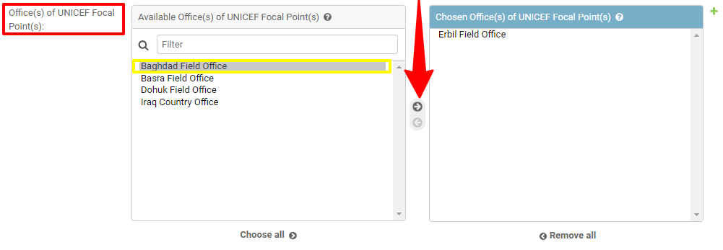
- To remove Office of UNICEF focal point:
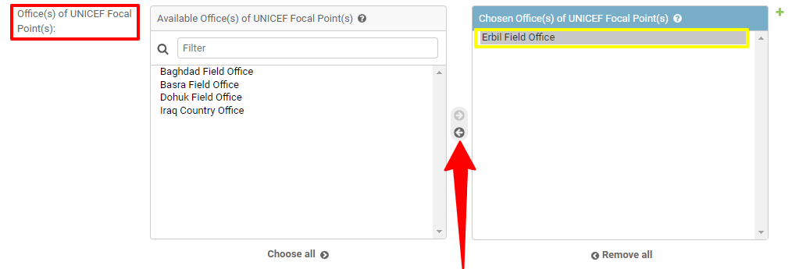
- Click on the save button at the bottom of the page.

- Mark or unmark an Activity as programmatic visit.
- At the bottom of the page, Tick (to mark) or untick (to unmark) the activity/task as a Programmatic visit (once Mark, it will show in the HACT Dashboard if the visit is UNICEF Approved)

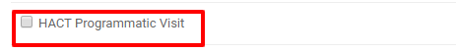
- Click on the save button at the bottom of the page.

IMPORTANT!

The CO Administrator will also be able to perform the below functions in Partnership Management Module. However, we strongly advise you against doing these. eTools Partnership Management Portal is not designed to be run from the admin panel and you must be aware that when you perform certain functions, there can be consequences which is why we support only minimum changes possible to the system. If you need to perform any of the below stated functions, we recommend that you contact eTools Product Manager Nikola Trncic at ntrncic@unicef.org

- Agreement (PCA, SSFA) data:
  - Change start date
  - Change Signed by UNICEF and Signed by Partner dates
  - Change Reference Number

- Intervention (PD, SSFA) data:
- Change Document Submission Date by CSO
- Change Document Submission Date to PRC and Review Date by PRC
- Change Start and End dates
- Change Signed by UNICEF and Signed by Partner dates
- Change Reference Number
- Change Planned Budget amounts (UNICEF Cash, UNICEF Supply, CSO contribution)
- Change Planned Budget currency

What functions I will not be able to perform as Country Office Administrator?
As a Country Office Administrator you cannot perform the following functions:
- Delete or amend FR numbers
- Assign user permission rights such as “Partnership Manager” to users
- Assign of change workspaces in eTools for users
Please note that only eTools Regional Support Specialists or members of eTools Team in New York have the authority to perform the above functions. If you need assistance, please contact us via the support service icon in eTools.
IMPORTANT!
Please keep in mind that if you delete anything from the eTools Admin Panel, you will not be able to retrieve it and the affected data must be re-entered in eTools.

How do I assign CO Administrator role to a staff member?
Please nominate one or two eTools focal points from your Country Office to receive the Country Office Administrator role. You can send their names to your Regional Support Specialist or eTools Product Manager Nikola Trncic (ntrncic@unicef.org) who will then conduct a demo on the features of this role.

