Instructions for Accessing eTools Datamart Dataset in Power BI
In a blank Power BI file in Power BI Desktop, first ensure that you are logged in using your UNICEF account. Your name will appear in the upper right corner. Next, in the Get Data dropdown, select “Power BI datasets.”

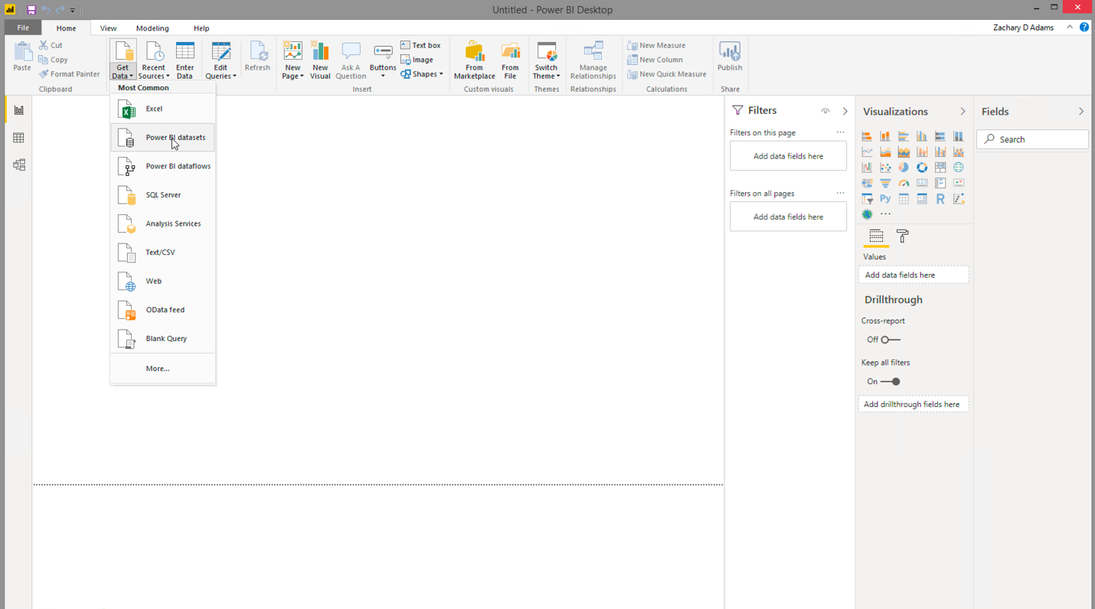

In the modal, scroll or use the search function to find “eTools Datamart Data.”
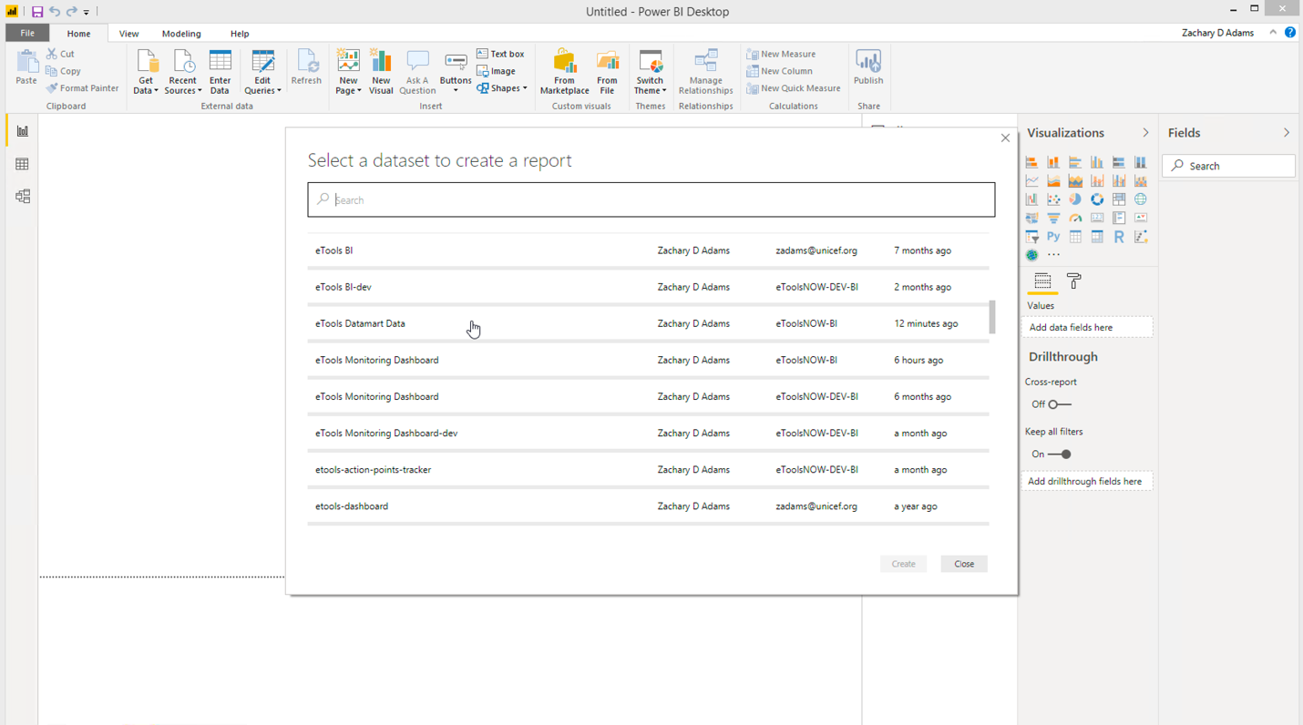
Power BI will quickly fetch the most up-to-date tables and data for you to work with. The data will be updated daily.
